**iOS**

* iOS is iPhone Operating System that run on apple devices
* iOS is operating System it is used to run iphone, ipad , and iPod application .
* It is developed by Apple Company for all the mobile devices.
* The iOS operating System it is used to to manage and handle the hardware devices and technology is used to to implement the native apps.
* The iOS Software Development Kit contains tools and interfaces it is used to develop, install, run and test native apps.  
  Native apps built by using Objective C language iOS System frameworks and objective C language and run directly on ios .

The iOS Layers Architecture:

* The Highest level iOS acts as intermediate Between underlying hardware and apps you create.
* Apps will not talk directly to the underlying hardware instead of it communicate with the set defined interfaces. These interfaces is easy to write apps that work consistently on devices and having different hardware capablities.
* ios Technology packaged as Frameworks.
* Apple delivers most of system interfaces in special packages called as framework.
* Framework: A Framework is an directory it contains dynamic library and resources such as header files, images, methods it need to support that you

to be want to use the frame work you add them to your project in xcode.

**Layers Of iOS:** 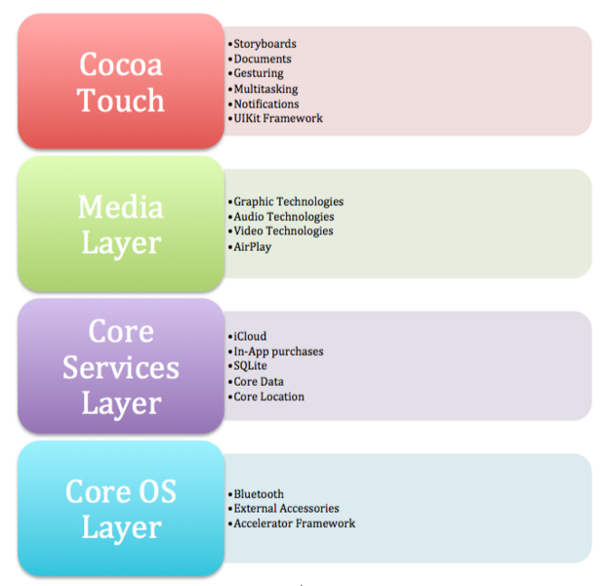

**I)Cocoa Touch Layer**:

* The Cocoa Touch Layer it contains key framework for building iOS apps.
* These framework define appearance for your app.
* Cocoa Touch Layer also provides basic app infrastructure and also support key technology such as multitasking, touch-Screen, push notifications( notify a user of new messages or events even when the user is not actively using your application) and also provide high level System Services.

**Key technologies available in the Cocoa Touch layer:**

**i):App Extension**: app Extension you extend custom functionality and content Beyond your app. make it useful for user while using other apps or the system.

**Several types of app extension:**

|  |  |
| --- | --- |
| Extension Point | Typical Extension Functionality |
| Share | Post sharing website or share content with others. |
| Photo Editing | Edit a photo or video within the Photos app. |
| Custom Keyboard | Replaces custom keyboard for ios app |

**ii) Handoff**: Handoff means exchanging things from one to another .

* Handoff feature is available in OSx and iOS.
* handoff User begin activity with One user and switch to another device.

**Example:** User is using Browser safari in Mac can move to iOS Device signed into icloud into same Apple ID and opens same webpage automatically in safari on iOS .

**iii)Document Picker:**

* iCloud Drive and its associated Document Picker are new features of iOS 8 that allow the app you're using to open files created in a diffeent app, import them, move them.
* Document Picker feature is user select document from outside app.
* documents stored in iCloud Drive and documents provided by a third-party extension.

**iCloud Drive**: It  is Apple's online storage service — a place to keep all your files and access them from all your Apple devices, including your iPhone, iPad, and Mac.

**iv) AirDrop:**

* AirDrop introduced in iOS 7 we can beam files from one **iPhone**, iPod touch, or iPad to another over a secure, ad-hoc Bluetooth and Wi-Fi connection.
* By using AirDrop we can share photos, documents, and messages
* We can send files to other device using UIACTIVITYCONTROLLER class.
* By using this class we can get different option for sharing the contents.

**v)TextKit:**

* TextKit is full featured high level set of classes is used for handling text and typography (Means the art or procedure of arranging type or processing data and printing from it)
* Using Textkit :
* You can flow text around arbitrary region as graphics and
* you can used to manage multiple fonts.
* you can make styled text into paragraph, columns, and pages.
* TextKit is integrated with all UIKit text-based controls to enable apps to create, edit, display, and store text.

**vi)UIKitDynamics:**

* Apps can now spcify dynamic behavior for UIView Objects that conformts to the UIDynamic Protocol. Objects that conforms to this protocols are called dynamic items.

**UIkit dynamic Behaviour Types:**

* UIAttachmentbehavoiur, UI collision Behaviour, UIGravity Behaviour, UIPush Behaviour, UISnapBehaviour.

**vii)Multitasking:**

* With Multitasking, you can use more than one app at a time on your iOS device. You can also use features like Slide Over, Split View, and Picture in Picture on certain iPad models.
* Battery Life is most important for iOS devices.
* Multitasking model it is designed to maximize the battery life .
* when User presses the Home button, the foreground app shifts to a background execution .
* If app has no work then suspended from active mode and put into freeze -dried state. means it remains in memory but it will not execute any code .

**viii) AutoLayOut:**

* Auto Layout calculates the size and position of view in your view hierarchy.
* Auto Layout used to define rules for how to layout the elements in user interface.
* The entries used in Auto Layout are Objective -C Objects called as Constraints.
* For example: constrain a button so that it is horizontally centered with an Image view and so that the button’s top edge always remains 8 points below the image’s bottom. If the image view’s size or position changes, the button’s position automatically adjusts to match.

**ix)Storyboards:** Storyboard introduced in iOS 5.

* Storyboards help us create all the screens of an application and interconnect the screens under one interface MainStoryboard.
* It also helps in reducing the coding of pushing/presenting view controllers.
* Means all views and view Controller design in one place .and see how they work together.
* storyboards is the ability to define segues(means changing from one state or situation to another), which are transitions from one view controller to another.

**x)UI State Preservation:**

* State preservation is for users by having your app appear to be always running.
* If system occurs memory pressure it will force to terminate one or more background apps.
* When an app moves from the foreground to the background, it can preserve the state of its views and view controllers.(Means it will maintain in Original state).

**xi)Apple Push Notification Services:**

* It provides service for user to alert new information even when your app is not running.
* Using this service you can push the text notification, trigger audible alerts on user devices at any time.
* These messages to open your app to receive related information
* In Ios 7 even if you push silent notification like that Episodic content—TV shows, podcasts.

**xii)Local Notification:**

* Local notifications and remote notifications are called user notification
* Local notifications complement the existing push notification mechanism by giving apps a way to generate the notifications locally instead of relying on an external server.
* when App running in background can use local notification is used to get user attention when any important event exist
* Advantage of local notifications is that they are independent of your app. After a notification is scheduled, the system manages the delivery of it. Your app does not even have to be running when the notification is delivered.

**xiii)Gesture recognizers:**

* A Gesture recognizer is actually an object of the abstract class UIGesture Recognizer. Such an object is related to a view, and monitors for predefined gestures made on that view.
* Gestures are actually touches and movements of one or more fingers that happen on a specific area of the screen, where a view of interest exists there.
* In the early versions of iOS SDK, gestures recognizers were not provided to developers, so implementing such ways of interaction required a lot of manual work. UIKit supplies standard gesture recognizer subclasses to detect taps, pinches, pans, swipes, rotations.

**xiv)Standard System View Controllers**:

* Many System framework define view controller for standard system interfaces.
* View Controller is used to perform Some tasks:
* **Display or edit contact information:** To view controllers in the Address Book UI framework.
* Create or Edit Calendar: To view controllers in the EventKit UI framework
* **Compose an email or SMS message:** To view controllers in the Message UI framework.
* **Open or preview the contents of a file:** To [UIDocumentInteractionController](https://developer.apple.com/library/ios/documentation/UIKit/Reference/UIDocumentInteractionController_class/index.html#//apple_ref/occ/cl/UIDocumentInteractionController) class in the UIKit framework.
* **Take a picture or choose a photo from the user’s photo library.** Use the [UIImagePickerController](https://developer.apple.com/library/ios/documentation/UIKit/Reference/UIImagePickerController_Class/index.html#//apple_ref/occ/cl/UIImagePickerController) class in the UIKit framework.
* **Shoot a video clip:** To use [UIImagePickerController](https://developer.apple.com/library/ios/documentation/UIKit/Reference/UIImagePickerController_Class/index.html#//apple_ref/occ/cl/UIImagePickerController) class in the UIKit framework.

**Cocoa Touch Frameworks:**

**i) Address Book UI Framework:**

* The Address Book UI framework uses (AddressBookUI.framework).
* The Address Book UI framework is Objective C programming interface that is used to display standard system interfaces for creating new contacts and editing existing contacts.

**ii)EventKit UI Framework:**

The EventKit UiFramework is to provide view controller for presenting standard system interfaces for viewing and editing calendar events

**iii)MapKit Framework:**

* The Map Kit framework provides an interface for embedding maps directly into your own windows and views.
* This framework also provides support for annotating the map, adding overlays, and performing reverse-geocoding lookups to determine place mark information for a given map coordinate.
* The MapKit framework it provide a scrollable map that you can incorporate into your app’s user interface.
* From the Maps app, users can delegate the providing of directions to any app that supports directions.

**iv)Message UI Framework:**

* Message UI framework provide support for composing emails or SMS.
* The composition support consist of view controllee present in app.
* The fields for view controller for to set recipients, subject, body content and also any attachment to message.
* After presenting the view controller, the user then has the option of editing the message before sending it.

**v)Notification Center Framework:**

* It provides support for creating widgets that display information in Notification Center.

**vi)iAd Frameworks:**

* It is Mobile advertisement Platform.
* It is used to Banner Advertisement for your apps.
* iAd facilitates integrating advertisements into applications sold on the iOS [App Store](https://en.wikipedia.org/wiki/App_Store_(iOS)). If the user taps on an iAd banner, a full-screen advertisement appears within the application,
* The views themselves work with Apple’s iAd Service to automatically handle all the work associated with loading and presenting rich media ads and responding to taps in those ads.

**vii)PushKit Framework:**

* It provides registration support for VoIP Apps. means Voice Over Internet Protocol.

**viii)UIKit Framework:**

* UIKit Framework it used for implementing graphical representation in iOS.

**Some of other features**:

* User interface management, including support for storyboards and nib files
* A view controller model to encapsulate the contents of your user interface
* Objects representing the standard system views and controls.
* Support for handling touch- and motion-based events.
* Support for a document model that includes iCloud integration .
* Graphics and windowing support, including support for external displays
* Multitasking support.
* Printing support.
* Support for customizing the appearance of standard UIKit controls.
* Support for text and web content.
* Cut, copy, and paste support.
* Support for animating user-interface content.
* Integration with other apps on the system through URL schemes and framework interfaces.
* Accessibility support for disabled users.
* Support for the Apple Push Notification service; see [Apple Push Notification Service](https://developer.apple.com/library/ios/documentation/Miscellaneous/Conceptual/iPhoneOSTechOverview/iPhoneOSTechnologies/iPhoneOSTechnologies.html#//apple_ref/doc/uid/TP40007898-CH3-SW26)
* Local notification scheduling and delivery; see [Local Notifications](https://developer.apple.com/library/ios/documentation/Miscellaneous/Conceptual/iPhoneOSTechOverview/iPhoneOSTechnologies/iPhoneOSTechnologies.html#//apple_ref/doc/uid/TP40007898-CH3-SW7)
* PDF creation.
* Support for using custom input views that behave like the system keyboard
* Support for creating custom text views that interact with the system keyboard
* Support for sharing content through email, Twitter, Facebook, and other services

**UIKit provide some other features:**

* The built-in camera (where present)
* The user’s photo library
* Device name and model information
* Battery state information
* Proximity sensor information
* Remote control information from attached headsets